Source / oracle 12c | Target / Tibero 6
Verify data / Consistent data | Verify data / Consistent data
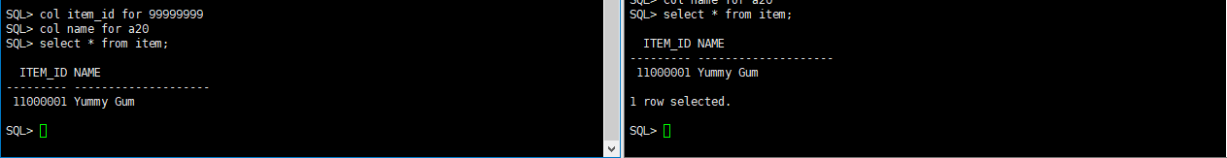

Insert Data | No Action
Insert into item values (11000002, ‘Albert Lu’);
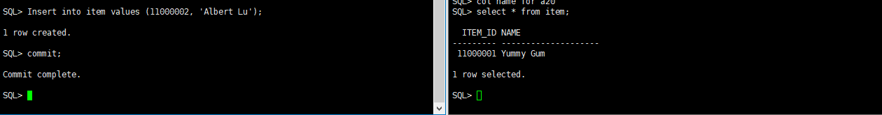

Verify data | Verify data
select * from item; | select * from item;
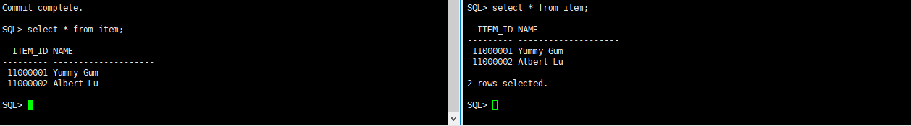

Update Data | No Action
update item set name = 'Popo Wu'
where item_id = 11000002;
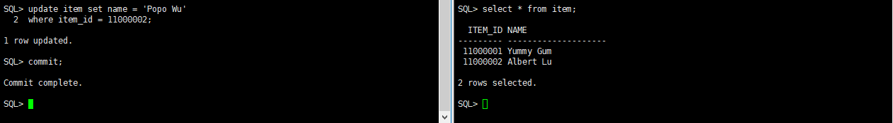

Verify data | Verify data
select * from item; | select * from item;
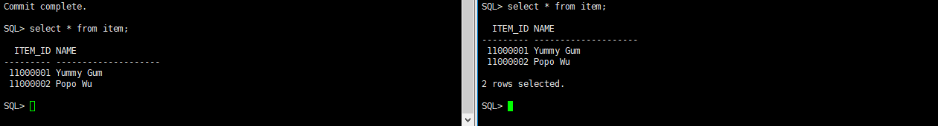

Update Data | No Action
update item set name = '臺灣國'
where item_id = 11000002;
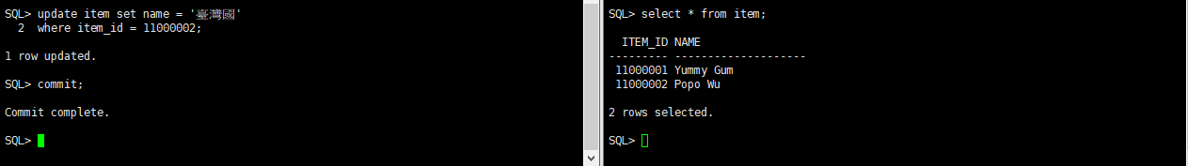

Verify data | Verify data
select * from item; | select * from item;
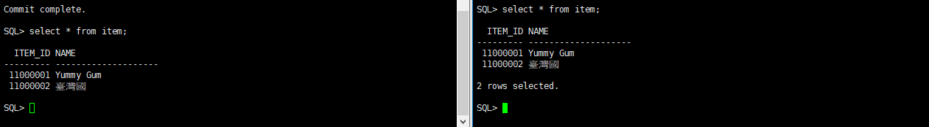

Create table | No action
create table symm.test1 (
id number not null,
name varchar2(30),
value varchar2(60));

Add new channel_id for new table | No action
INSERT INTO SYM_CHANNEL(channel_id, data_event_action, create_time, last_update_by, last_update_time)
VALUES ('test1',NULL,SYSTIMESTAMP,'admin',SYSTIMESTAMP);
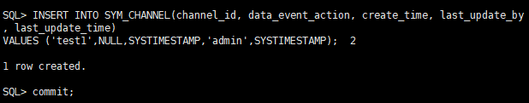

Add new trigger_id for new table | No action
insert into SYM_TRIGGER(trigger_id,source_table_name,channel_id,last_update_time,create_time) values('test1','test1','test1',systimestamp,systimestamp);
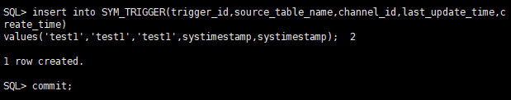

Add new trigger_router for new table | No action
insert into SYM_TRIGGER_ROUTER(trigger_id,router_id,initial_load_order,create_time,last_update_time) values ('test1', 'corp_2_store', 1, systimestamp, systimestamp);
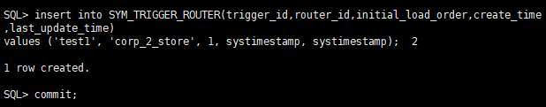

Add new trigger_router for new table | No action
./bin/symadmin reload-node 001
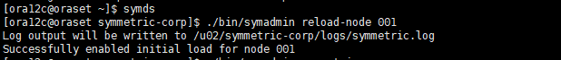

Insert data into test1 | No action
insert into test1 (id, name) values (99, '測試');
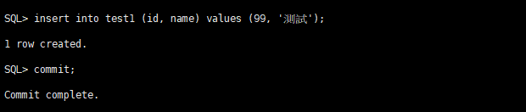

Verify data | Verify data | No action
select * from test1; | select * from test1;
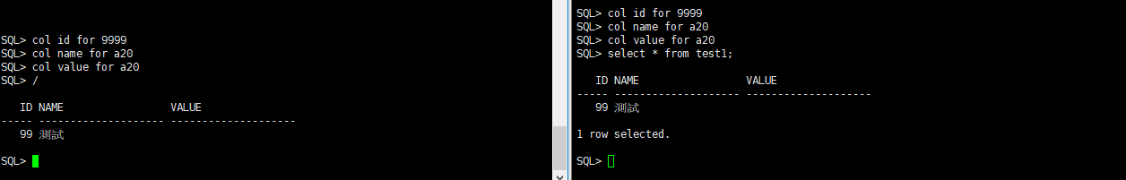

No Active | 2020-09-12 13:51:16,488 ERROR [store-001] [HeartbeatJob] [store-001-job-7] Exception while executing job 'Heartbeat' StackTraceKey.init [SqlException:1427445761] org.jumpmind.db.sql.SqlException: JDBC-11048:"SYMM"."SYM_DATA"."SOURCE_NODE_ID" The value is too large for the column. (Actual value: 157, Maximum value: 50)  TBR-15163: Unhandled exception at SYMM.SYM_ON_U_FOR_SYM_ND_HST_STR, line 32.
 | 